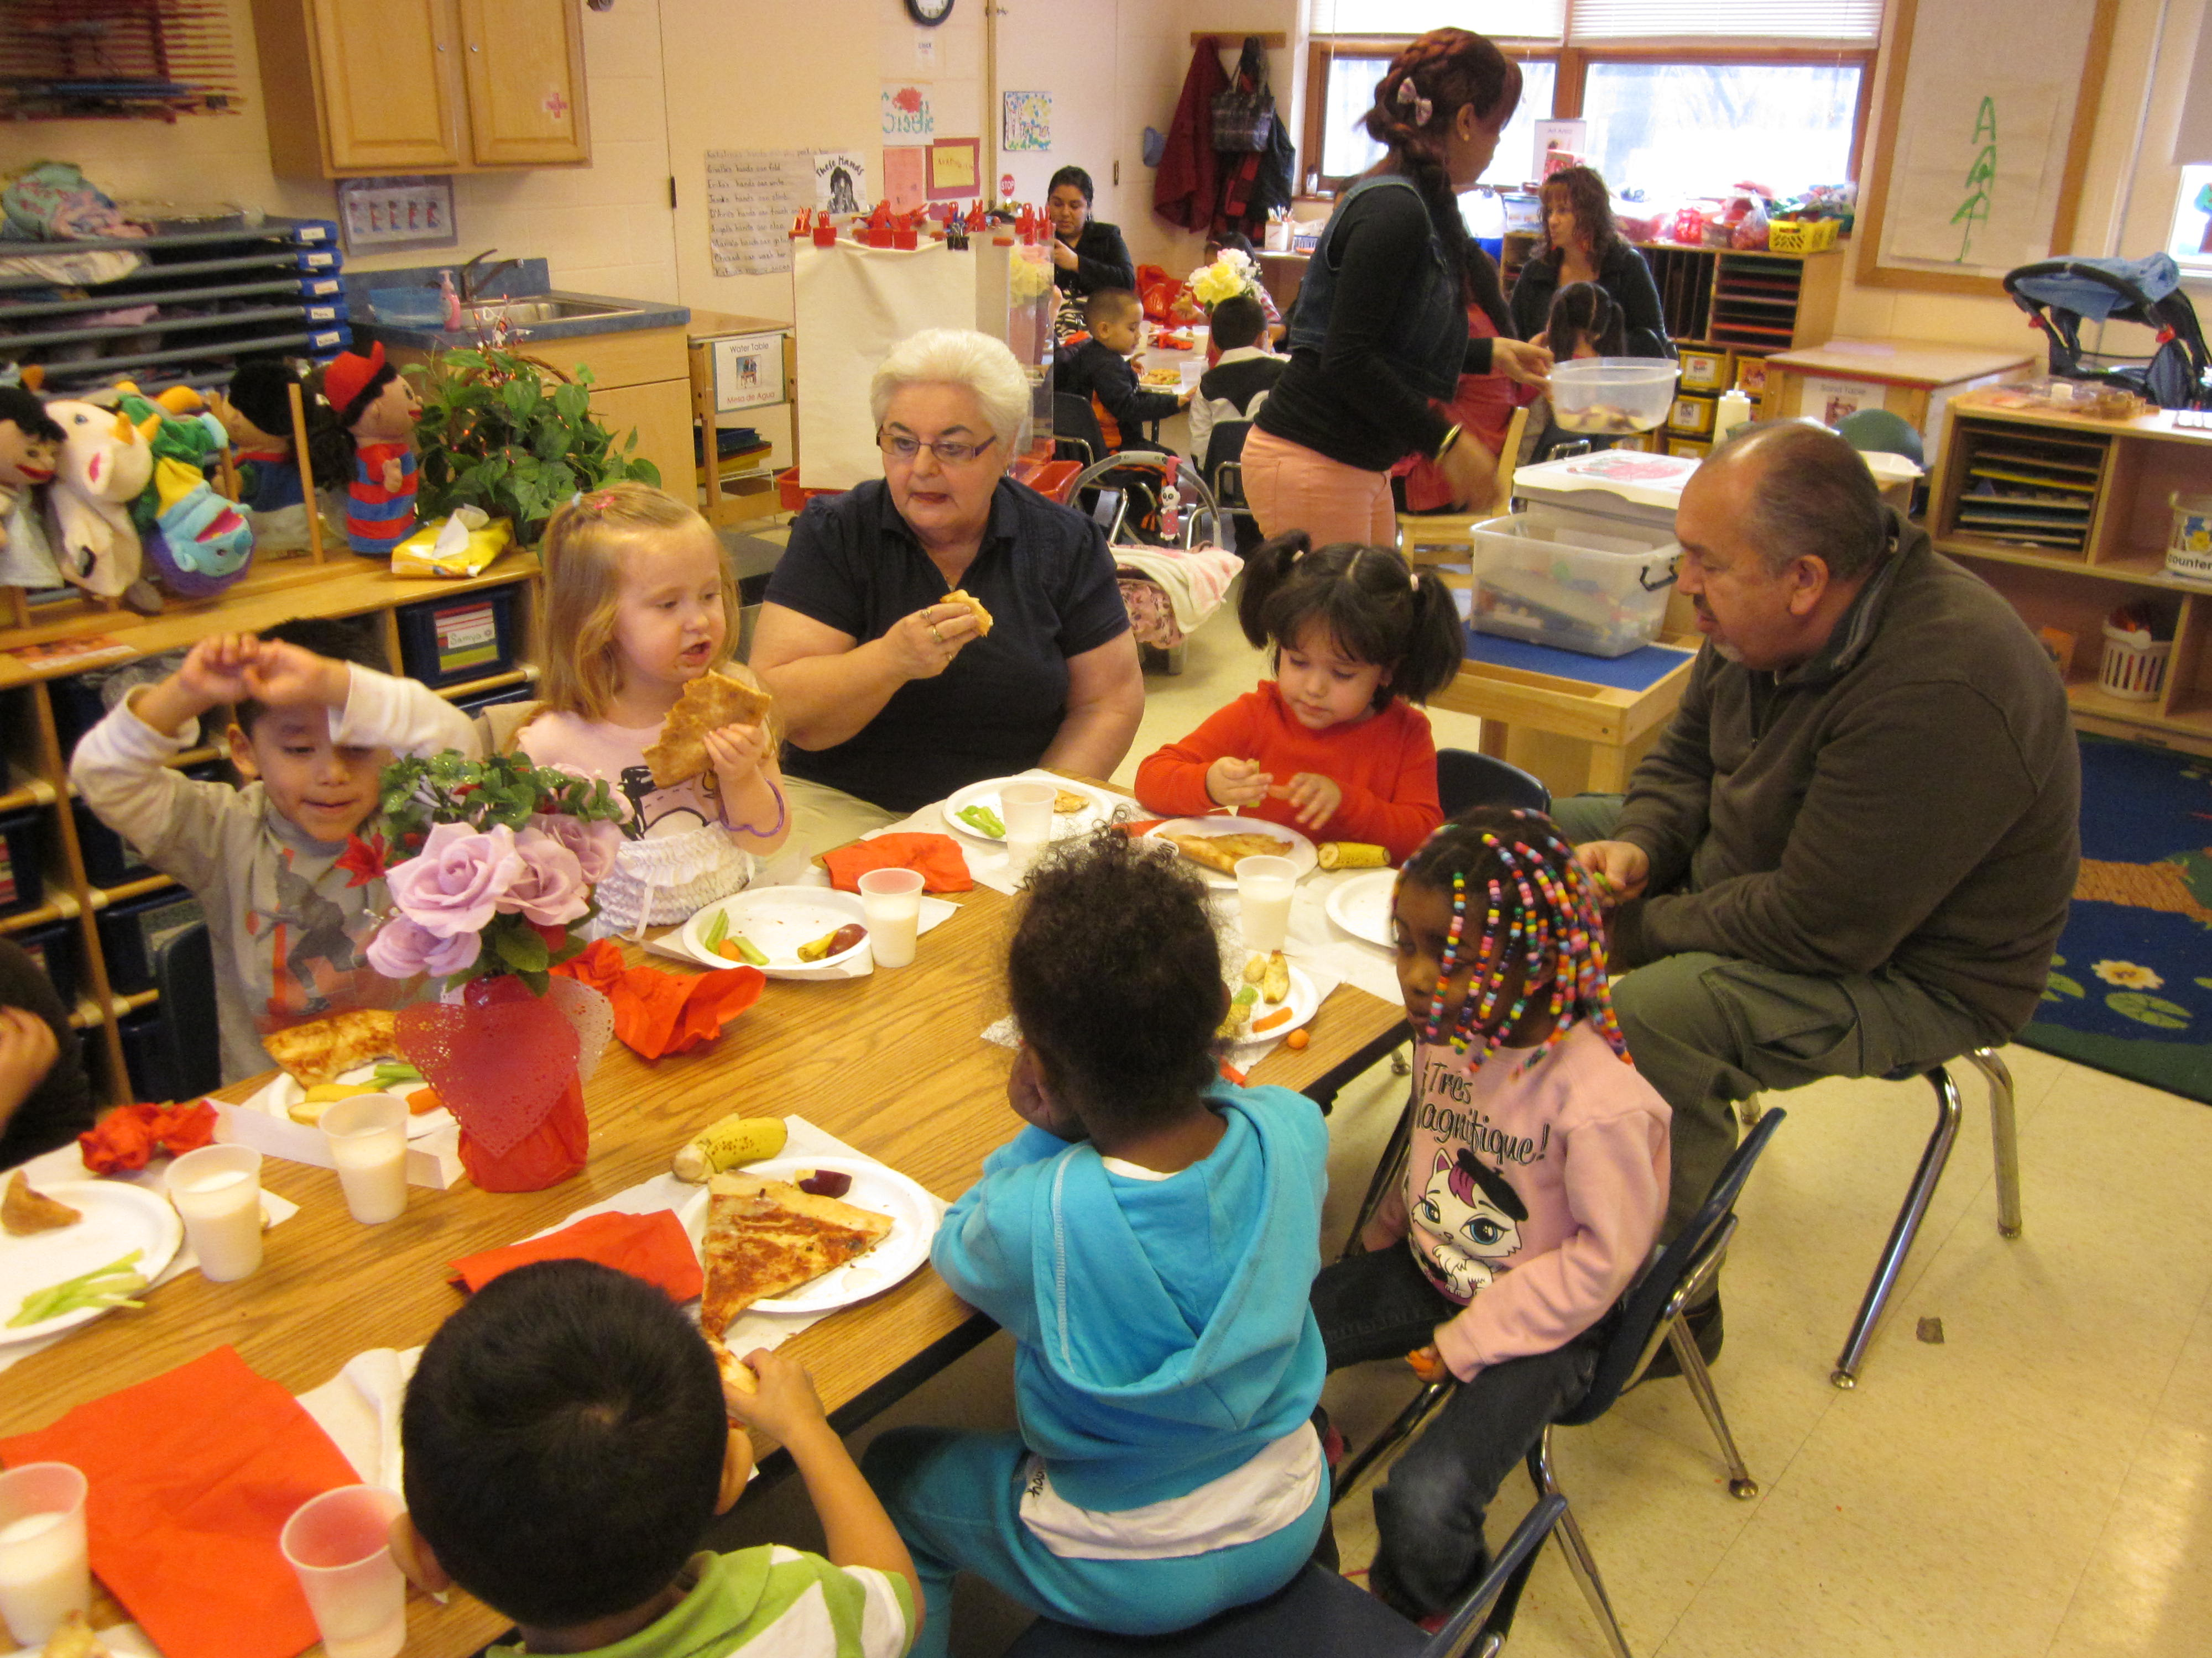

During this important time in your child’s life, we encourage you to become as involved as you are able. By getting involved you increase your child’s self-esteem, strengthen the Courtyard School Community, and develop your own leadership skills. Parent involvement is the key to your child’s educational success. You are the voice of your children, you know as parents what you want for your child’s education, let’s join together to ensure your child’s school experience leads them to a prosperous future. We are not only looking for parents who want to help in the classroom and for parent nights, we are also looking for leaders. There are many groups in our community that need parents to join and support our children’s education. We need leaders to represent The Courtyard School. We need you!

**Goals of C.P.S.A**

* **Having parents volunteer**
* **Help with fundraising**
* **Help with school projects & events**
* **Represent our school on the *Cumberland County Council for Young Children***
* **Help us plan social activities for our school**

**We’ll provide:**

* **The place to meet**
* **Leadership training**
* **Certificate of your involvement for work references**
* **Refreshments & childcare for meetings**

### The Courtyard Parent Support Association

### *We invite you to join the C.P.S.C. so that together we can collaborate to succeed in one of the most important aspects of your child’s education!*